A Paper Review about the “Controlling Many Differential-Drive Robots with Uniform Control Inputs” by Aaron Becker, Cem Onyuksel, Timothy Bretl, and James McLurkin

Yu Huang

1. **Goals**

The major goal of this paper is to propose both open-loop and closed-loop control policies that steer a finite set of differential-drive robots whose characteristic dimensions are various but actuated by a uniform signal to desired positions in a two-dimensional workspace. And prove the feasibility of the steering policies via MATLAB simulation and hardware experiments in order to illustrate that this policies are possible to be applied to the control of large ensemble of the next generation of Micro- or Nano-robots.

1. **Assumptions**

The paper used the two parameter and v to quantify the terminology of “non-holonomic”, that is different and scale the input into different forward speed and rotation speed:

[1]

The paper also assumed that the controlled balls roll on the two-dimensional workspace without slipping on the surface of the working panel.

1. **Limitations**

The paper mainly studied the condition of the unidirectional unicycle control. It investigated specific problem like how many degree of freedom can be freely manipulated by the inputs and which can be controlled but with constrains. On implementing the control policies, the author specified the term which describe the configuration of robots like “range”, “bearing” and showed how to control them.

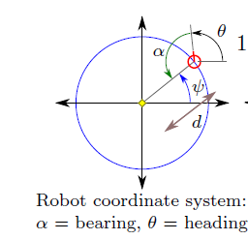

Fig.1. defined configuration[1]



Fig.2. control the heading and bearing. [1]

Besides, it also studied the error of the control and pointed out the by the utilization of the close-loop control, the error of the control can be decrease. Still, the manipulation is based on the two-dimensional workspace which means it has a long way to go to implement its application on the promising target deliver of medicine. As for the closed-loop control, although it can decrease the error of the policy, the convergence efficiency was affected remarkably by the increase of the robots population. Therefore, this will restrict the use of it in the realm of controlling large number of Micro and Nano-robots.

**Reference:**

[1] Aaron Becker, Cem Onyuksel, Timothy Bretl, and James McLurkin “Controlling Many Differential-Drive Robots with Uniform Control Inputs”. June 10, 2014